David L. Suddjian
Biological Consulting Services

801 Monterey Avenue, Capitola, CA 95010
Telephone 831· 479· 9603, email dsuddjian@aol.com

Summary of 2008
Marbled Murrelet Monitoring Surveys

In The Santa Cruz Mountains

Prepared for

Command Oil Spill Trustee Council

Prepared by

David L. Suddjian
Biological Consulting Services
801 Monterey Ave., Capitola, CA 95010

May 1, 2009
ABSTRACT

Monitoring of Marbled Murrelet activity using protocol-level audio-visual surveys continued in the Santa Cruz Mountains in 2008 at Big Basin Redwoods, Portola Redwoods, and Butano State Parks, and at San Mateo County Memorial Park. Murrelet activity decreased at all four parks, establishing new lows for Big Basin, Butano and Memorial, and a new low for all four parks combined. Detections of below-canopy flights were very infrequent, suggesting a very low incidence of nesting. The period 2003-2008 had significant declining trends for both total detections and occupied site behaviors for all parks combined. Declining trends for the two areas with longer-term data sets – Big Basin Park (from 1995) and Peter’s Creek Bridge in Portola (from 1992) – continued to be highly significant. Corvid numbers recorded in the vicinity of murrelet survey stations exhibited varied patterns of change. American Crows were recorded at Big Basin and Memorial Parks during the murrelet nesting season for the first time in 2008, although crows did not reside through the season in either park. Observations of raptors in the parks are described.

INTRODUCTION

This report presents the results of Marbled Murrelet (Brachyramphus marmoratus, hereafter referred to as “murrelet”) monitoring surveys conducted in 2008 for the Command Oil Spill Trustee Council (COSTC) in the Santa Cruz Mountains at Big Basin Redwoods State Park, Portola Redwoods State Park, Butano State Park, and San Mateo County Memorial Park (Figure 1). These surveys were commissioned to assist the COSTC in restoration planning for potential projects benefiting the murrelet.

Methods

Study Design

Dawn surveys were conducted at five stations in Big Basin, and at two stations each in Portola, Butano, and Memorial (Figure 1). Coverage at Butano, Memorial and one of the Portola stations was begun in 2003 to augment an existing long-term program of monitoring already established at Portola (since 1992) and Big Basin (since 1995). Since 2003 each station in each park has been surveyed three times annually from June to July, with two surveys at each in July. Two additional surveys are conducted at one of the Portola stations so that surveys occur there on three consecutive mornings in late June to continue a pattern of coverage begun at that station in 1992. Total annual surveys for each park are 15 at Big Basin, eight at Portola, and six each at Butano and Memorial.

Location of Survey Stations

Criteria for station placement and the selection of sites were described in Suddjian 2004.

The five stations at Big Basin (“Redwood Meadow”, “100 Acre Woods”, “Blooms Creek”, “Huckleberry”, and “Sempervirens”) were established in 1995 in a dispersed array in the upper watershed of the East Fork of Waddell Creek (Figure 2). “Redwood Meadow” station is at the meadow near the beginning of the Redwood Trail. “100 Acre Woods” station is on the North Escape Road at that road’s northern crossing of Opal Creek. “Blooms Creek” station is along East Ridge Trail east of Blooms Creek Campground. “Huckleberry” station is near site #13 in the tent cabins area of Huckleberry Campground. “Sempervirens” station is east of the Sempervirens Reservoir access road, midway between the reservoir and Sky Meadow Road Road.

At Portola (Figure 3) the “Peters Creek Bridge” station (established in 1992) is located on the bridge adjacent to the park’s main campground. “Iverson” station (established in 2003) is located where Iverson Trail crosses Pescadero Creek west of park headquarters (Figure 3).

At Butano (Figure 4), “Ben Ries” station (established in 2003) is on the main park road 50 meters before the road enters Ben Ries Campground, adjacent to campsite #1. “Little Butano Creek” station (established in 2003) is at a landslide along the park service road that begins at the entrance to the campground.

At Memorial (Figure 5), “Sequoia” station (established in 2003) is in the Sequoia Flat Campground where the main camp road enters the “D” section of the camp, adjacent to campsite #D6 (formerly named D1). “Memorial” station (established in 2003) is at Pescadero Creek adjacent to the Tan Oak Flat Picnic Area, at the site of the “swimming pool” that was formerly created seasonally in the creek.

Dawn Murrelet Surveys

Dawn murrelet surveys followed the standard protocol for audio-visual surveys in forests (Pacific Seabird Group 2003). David Suddjian conducted all the surveys. In addition to the murrelet survey data, all bird species detected were recorded (noting initial time, estimates of numbers, and other pertinent information), and two unlimited distance point counts were conducted during each dawn survey (Appendix 1). The point counts lasted 10 minutes and began at 0-5 minutes and 45 minutes after sunrise. Additional details of observations of Common Ravens (Corvus corax) and raptors (direction, distance, behavior, etc.), and a best estimate of the maximum number of Steller’s Jays (Cyanocitta stelleri) noted during each survey were also recorded.

Seasonal Timing of Coverage

Survey dates for each park in 2008 are given on Table 1. An effort was made to schedule coverage at each station on dates close to survey dates of previous years.

Additional Information on Murrelet Occurrence at Big Basin

Appendix 2 presents a summary of survey results from the Redwood Meadow / Park Headquarters parking lot of Big Basin. A total of 222 surveys following the same methods as those of this study have been completed at this site since 1991, representing the longest unbroken series of data for murrelets from any site in the Santa Cruz Mountains. This data set offers an opportunity to examine longer-term trends, and samples a broader part of the murrelet’s breeding season than do the June-July surveys conducted for the COSTC. In 2008 Suddjian conducted 16 additional surveys at the Redwood Meadow / Park Headquarters parking lot area from April 21 to July 27, in addition to the three for the COSTC contract.

Appendix 3 presents a summary of results from a USGS Breeding Bird Survey (BBS) route sampled by Suddjian from 1992 to 2008 that begins at Big Basin. While the BBS method is not specifically designed for monitoring murrelets at forest sites, it does provide a repeated measure of activity, and coverage for the BBS at Big Basin was contemporaneous with the other monitoring efforts presented in this report.

Results

Marbled Murrelet

Dawn flight activity in 2008 is characterized below for each park. Subjective descriptors of “low, “moderate,” and “high” activity refer generally to total detection counts in the range of 0-10 detections, 11-50 detections, and >50 detections, respectively. Results of the 2008 murrelet surveys are shown on Table 1. Tables 2 and 3 compare annual average activity at each station and park.

Big Basin Redwoods State Park

Activity remained very low in 2008 compared to the park’s known history of high activity, continuing the pattern of the most recent years (Suddjian 2003a, 2003b, 2004, 2005a, 2005c, 2008a, 2008b) (Table 2, Figures 6 and 7). The 15 surveys produced 60 total detections, and just seven detections of below canopy flights. Nine surveys (60%) had no detections at all. As for most recent years, there was no peak in activity during July. There were no detections of particular behavioral interest.

The area around “Redwood Meadow” remained a general hub for murrelet flight activity in the East Fork Waddell watershed. Surveys at “Redwood Meadow” in 2008 produced 60% of all detections recorded in Big Basin. Activity levels ranged from low to moderate (7-22 detections), but there were no detections of occupied site behavior (Table 1), the first year such activity has not been seen at this station on any of the COSTC surveys (Table 2). None of the detections observed in 2008 were strongly suggestive of birds visiting active nests.

Activity at “100 Acre Woods” was low to moderate (0-20 detections), with activity recorded on only one of three surveys (Table 1). Seven below canopy detections on the June 16 survey were the only occupied site behaviors recorded in Big Basin Redwoods SP on the 2008 COSTC surveys. The June 16 survey recorded an intense bout of activity involving multiple detections of probably just three murrelets that were flying generally up and down Opal Creek and circling in the vicinity of the station. But no detections were recorded on the following surveys. This sporadic presence of murrelets in the vicinity of the station was similar to most other recent years.

“Huckleberry” had no detections on any of the surveys (Table 1).

Activity at “Blooms Creek” was low (0-3 detections), with murrelets noted on two of three surveys, but no detections of below canopy flights (Table 1). Each of the four total detections was at least 250 meters distant to the west or northwest of the station, with no activity detected near the station. No occupied site detections have been recorded at “Blooms Creek” since July 2001.

“Sempervirens” had no detections on any of the surveys (Table 1). There have been no detections on any of the 21 surveys at “Sempervirens” since activity was last noted there in July 2001.

Trends at Big Basin

Activity levels have remained relatively very low since 2002, following a major drop in activity from levels of the mid-1990s (Table 2; Figures 6 and 7). The average number of detections for all five stations combined was lower in 2008 than in any other year. The long-term decline was highly significant for total detections (r² = 0.812, p < 0.0001) and occupied site detections (r² = 0.690, p = 0.0008) (Figures 6 and 7). Each station individually exhibited the same general pattern of a decline from relative high activity in the beginning years of monitoring to relative low activity in recent years (Figure 8). Data collected in 2008 from the more extensive series of surveys at Redwood Meadow (Appendix 2) and from the BBS route (Appendix 3) continued to match the pattern of decline documented by this study.

Portola Redwoods State Park

Overall activity at Portola in 2008 was less than in 2007, and remained considerably lower than in 2003-2004 (Table 2, Figure 11). For the first time in any year for this park there were surveys (two) with zero detections (Table 2). The number of occupied site behaviors was similar to that in 2006 and 2007, and remained much lower than in 2003-2004 (Figure 12). There were no observations of particular behavioral interest during any of the Portola surveys.

Activity at “Peters Creek Bridge” was low to moderate (0-27 detections; Table 1). Just three below canopy flights were recorded over the five surveys. Patterns of activity around the station were similar to prior years, with detections in varied directions and extensive circling over the area.

Activity at “Iverson” was low to moderate (0-21 detections), with eight detections of below canopy flights on two of three surveys (Table 1). Some of the below canopy detections involved murrelets flying low over Pescadero Creek. The relatively low level of activity contrasted strongly with that noted in 2003 and 2004 (Suddjian 2004 and 2005a), when activity at “Iverson” had been among the highest of any station in this study (Table 2, Figure 13).

Trends at Portola

Three Consecutive June Mornings at Peters Creek Bridge. The only long term comparison available for Portola is for the surveys conducted on three consecutive mornings in late June at “Peters Creek Bridge” (Table 3). Activity in 2008 increased slightly from 2007, but compared to prior years, activity has been relatively low since 2002 (Table 3, Figure 9). Linear regression on average total detections over the whole period of 1992-2008 showed a significant declining trend (r² = 0.447, P = 0.006; Figure 10). The declining trend for occupied site detections was marginally significant over the whole period of 1992-2008 (P = 0.072), but was significant from 1995 onwards (r² = 0.678, P = 0.002).

Entire Season for Both Stations. The six-year period 2003-2008 showed a significant decline in total detections (r² = 0.545, P = 0.047), and a significant decline in occupied site detections (r² = 0.604, P = 0.034). The decrease is shown on Figures 11 and 12.

Butano State Park

Overall activity at Butano in 2008 was only about half of that of 2007, and was the lowest for the six year study period (Table 2, Figures 11 and 13). The number of occupied site behaviors also decreased to a new low for the six years of surveys (Table 2, Figure 12). There were no observations of particular behavioral interest during any of the Butano surveys.

Activity at “Ben Ries” ranged from low to barely moderate (5-13 detections), with no below canopy flight recorded in 2008 (Table 1). As in prior years, most flight activity was oriented toward Little Butano Creek or up the canyon to the east, and included detections of birds moving up or down the drainage. There were also a small number of detections close to the station and over the adjacent campground.

Activity at “Little Butano Creek” was moderate (14-29 detections), with 2-7 occupied site detections noted on two of the three surveys (Table 1). Activity at this station averaged the highest for any station in the study for the fourth year in a row, with 29 detections on July 2 being the most recorded on any survey in 2008. As in prior years, each survey recorded extensive movement by murrelets flying up and down the drainage, and circling over the canyon in the vicinity of the station, and upstream of the station.

Trends at Butano

The six-year period 2003-2008 showed non-significant declines for both total detections and occupied site detections (Figures 11 and 12).

San Mateo County Memorial Park

Overall activity at Memorial Park in 2008 decreased from 2007, and was the lowest recorded in the park over the six-year period (Table 2, Figures 11 and 13). As in prior years, the number of occupied site behaviors was very low: one detection (Table 1, Figure 12). There were no observations of particular behavioral interest during any of the Memorial surveys.

“Memorial” had very low activity, with single detections on two surveys (Table 1). Both were distant to the west.

“Sequoia” had no detections on the June survey, but moderate activity on July 14 (20 detections), and then low activity July 25 just (one detection; Table 1). Several detections were of murrelets circling broadly over the area. The lone occupied site detection was of two birds seen briefly just below the tops of the trees north of the station.

Trends at Memorial

The trend for the six-year period of 2003-2008 showed non-significant declines for both total detections and occupied site detections (Figures 11 and 12).

CORVIDS

Counts of Steller’s Jay and Common Raven from the dawn surveys at each station are given on Table 4. General summaries of numbers and activities around the murrelet survey station are given below. American Crows (Corvus brachyhrynchos) were detected in 2008 on several occasions at Big Basin, and three times at Memorial Park. These are detailed below under the headings for the respective parks.

Big Basin Redwoods State Park

Steller’s Jay

Steller’s Jay was detected on all surveys at all stations. The pattern of relative abundance among stations closely matched that of prior years, with highest abundance correlated with the proximity to campgrounds (Table 4). Overall jay abundance recorded during the murrelet surveys was similar to the previous two years (Figure 14).

Common Raven

Common Raven was detected on all surveys at all stations, except none were noted at 100 Acre Woods. Counts ranged from 0-5 per station (Table 4). Overall raven abundance recorded during the murrelet surveys decreased in 2008 (Figure 15). Territorial pairs resided near each of the stations where the species was recorded. Nesting productivity was moderate.

No exceptional roosts or other concentrations were noted in the study area in 2008.

American Crow

American Crows were not noted in the seasonal period of the murrelet surveys, but there were records before and after the survey season in 2008. Sightings of crows in early spring included: one flying west over park headquarters on February 27; two flying over the upper watershed of the north fork of Union Creek on March 3; two perched along China Grade near Tray’s Ranch on March 4; one flying over park headquarters on March 7; and one was in the vicinity of the upper junction of China Grade at Highway 236 on March 22 to April 11. In late summer one was along China Grade just south of the San Mateo County line on August 1. These are the only records for the interior region of Big Basin Redwoods State Park except for one that was shot at Huckleberry Campground on April 6, 2005. There was no indication of any resident crows in the interior region of the park during the 2008 breeding season.

Portola Redwoods State Park

Steller’s Jay

Steller’s Jay was detected on all surveys at both stations, with more tallied at “Peters Creek Bridge” (at the edge of the campground) than at “Iverson” (Table 4). Overall jay abundance recorded during the murrelet surveys was similar to that of 2007, and to 2003-2004 (Figure 14).

Common Raven

Members of a pair, joined in July by their fledglings, were noted on most surveys at “Peter’s Creek Bridge”, and a single recorded on two surveys at “Iverson” were likely part of the same pair (Table 4). This pair nested along Iverson Trail east of Tiptoe Falls, apparently using the same nest as in 2007. They fledged two juveniles by July 9, but by July 28 the adults were still present but no young were evident. The fate of the juveniles is unknown, but it was too soon after fledging for them to become independent and leave the area, so presumably they died. This was apparently the only pair residing on territory in the park in 2008.

Two adult ravens flying north high over “Peter’s Creek Bridge” on July 11 were the only “non-local” ravens seen during the dawn surveys. Elsewhere, a flock of nine adult ravens flying north over the vicinity of Slate Creek Trail Camp on July 28 were also considered “non-local.” Small flocks of such “commuters” were also noted at Portola in 2002, 2003, 2005, and 2007 (Suddjian 2003a, 2003b, 2004, 2005c, 2008).

Butano State Park

Steller’s Jay

Steller’s Jay was detected on all surveys at both stations, with similar numbers at each (Table 4). Overall jay abundance recorded during the murrelet surveys decreased slightly in 2008, reaching a new low for the six-year period (Figure 14).

Common Raven

A pair of ravens resided in the area of Ben Reis Campground and northeast of the campground. This is the same territory as occupied in other recent years. The roost or nest location was apparently some distance northeast of the campground, but there was no evidence of actual nesting in 2008 and no young were noted in the park. Another pair resided southwest of the murrelet survey areas, generally in the area southwest of Mill Ox Trail and the meadow along Goat Hill Trail

San Mateo County Memorial Park

Steller’s Jay

Steller’s Jay was detected on all surveys at both stations, with high numbers at Sequoia Flat (Table 4). Jay abundance increased in 2008, but was still below the peak of 2005. Jays remained considerably more abundant at Memorial County Park than the other parks (Figure 14).

Common Raven

Common Ravens were encountered on each survey at both stations in 2008 (Table 4). Raven numbers recorded during the dawn surveys dropped in 2008, and were on a par with the lowest numbers recorded in this park during this study (Figure 15). Fewer pairs nested in or near the park, and fledgling success was low.

There were no obvious “non-local” ravens recorded in the park in 2008.

American Crow

A pair of American Crows was interacting with a pair of ravens at Homestead Group Campground on May 16, 2008. One crow was found dead along Pescadero Road near the park’s west boundary on May 30. One crow noted on the July 22 dawn murrelet survey at “Memorial” station was the first to be noted during any murrelet survey for this study. It was first heard calling east of the station, near the Wurr Road bridge. It then moved to the Wurr Group Campground area, then north into the Tan Oak Flat Picnic Area. There were no records of American Crows in Memorial Park before 2008.

RAPTORS

Big Basin Redwoods State Park

An adult Sharp-shinned Hawk (Accipiter striatus) was at Blooms Creek Campground on May 10. One flew low over “Redwood Meadow” on July 16.

Cooper’s Hawks (A. cooperi) nested north of Sempervirens Reservoir (fledging three young by July 4), and near Slippery Rock (fledging three young by July 17). Hawks detected in other places included a male at Blooms Creek Campground on June 17-19, a female at Sempervirens Campground on June 20, and a female flying low at “Huckleberry” on July 18.

Red-shouldered Hawk (Buteo lineatus) was detected less often in 2008. There were about 15 detections total from June to July (down from 24 in 2007). It was recorded at three of the five murrelet survey stations (“Redwood Meadow”, “Huckleberry” and “Sempervirens.” Extensive field surveys by Suddjian for this study and other research in the park produced an estimate of four breeding pairs in the East Fork Waddell watershed in 2008, down from nine in 2007 and seven in 2006.

An adult Peregrine Falcon (Falco peregrinus) flying south along Middle Ridge at Ocean View Summit on June 4 was the only specific report known for the park in 2008, although there were unconfirmed reports of one or two present in the former breeding territory at Mt McAbee (fide J. Linthicum).

Barn Owl (Tyto alba), Western Screech-Owl (Megascops kennicottii), Northern Pygmy-Owl (Glaucidium gnoma), and Northern Saw-whet Owl (Aegolius acadicus) were heard in the study area this year.

Portola Redwoods State Park

A Sharp-shinned Hawk family with three fledglings was at Bear Creek near Peter’s Creek Grove on July 28.

A Cooper’s Hawk calling near the southeast side of the main Portola campground on June 27 attracted a mob of Steller’s Jays. Two fledglings were begging near the high point of the Bear Creek Trail on July 28.

Two pairs Red-shouldered Hawks resided in the area of the park visited for the murrelet surveys. One pair continued in the vicinity of “Iverson”, although nesting was not confirmed. Another pair was to the east in the vicinity of the Iverson Cabin site, with a nest located on June 24. A juvenile near the nest site on July 29 indicated it was successful.

Western Screech-Owl and Northern Pygmy-Owl were noted in the study area.

Butano State Park

A pair of Sharp-shinned Hawks nested for the second year in a row at the north margin of Ben Ries Campground, fledging three young between July 2 and July 23. One of the three juveniles was caught and killed by a Red-shouldered Hawk on July 25! The male of the nesting pair was seen foraging as far as 0.2 and 0.3 mile from the nest site area.

An adult Cooper’s Hawks was calling just east of the campground on June 12. None were noted subsequently until August 8, when an adult was at the campground and a juvenile was begging east of the campground.

A pair of Red-shouldered Hawks continued to reside to the south, sometimes visiting the campground area, and extending east to Goat Hill Trail and south to Año Nuevo Trail. None were detected upstream of the campground this year.

Western Screech-Owl and Northern Pygmy-Owl were heard in the study area this year.

San Mateo County Memorial Park

No Accipiters or Peregrine Falcons were detected in Memorial Park this year, the latter missing after being present from 2005-2007.

Red-shouldered Hawks continued to be numerous in and adjacent to Memorial Park in 2008. There were at least three or four pairs at this park and surroundings in June and July, although it was difficult to sort out how many individuals or pairs were present among many detections. Up to six individuals were recorded at and adjacent to Sequoia Flat Campground on July 14, and up to eight individuals were in the park on July 23. Nesting was confirmed by the presence of juveniles beginning July 13, with young noted near both murrelet survey stations.

Barn Owl and Western Screech-Owl were recorded in the study area in 2008.

Discussion

In 2008 Marbled Murrelet activity decreased at all four parks, establishing new lows for Big Basin, Butano and Memorial, and a new low for all four parks combined (Figure 16). Decreases at Big Basin and Memorial were relatively minor, as activity levels were already very low in those parks. But activity dropped by nearly half at Butano, which has had more activity than the other parks in recent years. Detections of below-canopy flights, of the greatest interest as indicators of likely nesting behavior, remained very infrequent. This suggests a very low incidence of nesting, corroborated by a lack of juveniles observed on at-sea surveys in summer 2008 (Z. Peery pers. comm.).

Portola had the highest average flight activity in 2008, only slightly better than Butano, which had been most active for the prior four years (Figure 11). But two surveys at Portola with zero detections were the first ever to miss the murrelet in that park in the six years of this study. Big Basin and Memorial Park, each similarly low in activity, again ranked in third and fourth place, respectively (Figure 11).

The six-year period had significant declining trends for both total detections (r² = 0.660,
p = 0.025) and occupied site behaviors (r² = 0.615, p = 0.0532) for all parks combined. Declining trends for the two areas with longer-term data sets – Big Basin Park and Peter’s Creek Bridge in Portola – continued to be highly significant. Declining trends at Portola for the six-year data set covering this study were also significant.

American Crows occurred in Big Basin and Memorial Parks during the murrelet nesting season in 2008. There has been just one prior occurrence in the interior region of Big Basin before 2008, and none at Memorial. The five spring records at Big Basin in 2008, spanning February 27 to April 11, fit a pattern of seasonal wandering or dispersal exhibited by this species in the Santa Cruz Mountains, which is perhaps connected with prospecting for new nesting areas. Populations of resident American Crows are increasing in the general vicinity of both parks. In Santa Cruz County crows have continued to increase at towns in the San Lorenzo Valley and to extend their range far up the San Lorenzo Valley and up the Boulder Creek watershed, occurring now in regions that are predominantly forested. In San Mateo County crows are now resident at Pescadero, and that growing presence has perhaps led to the spring 2008 records at Memorial Park.

Literature Cited

Nelson, S. K. 1997. Marbled Murrelet (Brachyramphus marmoratus). No. 276 in The birds of North America (A. Poole and F. Gill, Eds.) Acad. Of Nat. Sci., Philadelphia, Pennsylvania, and the Amer. Orn. Union, Washington D.C.

Pacific Seabird Group. 2003. Methods for surveying Marbled Murrelets in forests: a revised protocol for land management and research. Marbled Murrelet Technical Committee. Unpubl. report dated 6 January, 2003.

Suddjian, D. L. 2001. 2001 Marbled Murrelet Monitoring Surveys at Big Basin and Portola State Parks. Unpubl. report. Prepared for the California Dept. of Fish and Game.

Suddjian, D. L. 2003a. Summary of 2002 Marbled Murrelet monitoring surveys
at Big Basin and Portola State Parks. Unpubl. report. Prepared for the California Dept. of Fish and Game.

Suddjian, D. L. 2003b. Summary of 2003 Department of Fish and Game Marbled Murrelet Monitoring Surveys At Big Basin and Portola Redwoods State Parks Unpubl. report prepared for the California Dept. of Fish and Game.

Suddjian, D. L. 2004. Summary of 2003 Marbled Murrelet Surveys in the Santa Cruz Mountains. Unpubl. report prepared for Command Oil Spill Trustee Council.

Suddjian, D. L. 2005a. Summary of 2004 Marbled Murrelet Surveys in the Santa Cruz Mountains. Unpubl. report prepared for Command Oil Spill Trustee Council.

Suddjian D. L. 2005b. Summary of 2004 Corvid Monitoring Surveys in the Santa Cruz Mountains. Unpubl. report prepared for Command Oil Spill Trustee Council.

Suddjian, D. L. 2005c. Summary of 2005 Marbled Murrelet Surveys in the Santa Cruz Mountains. Unpubl. report prepared for Command Oil Spill Trustee Council.

Suddjian, D. L. 2008a. Summary of 2006 Marbled Murrelet Surveys in the Santa Cruz Mountains. Unpubl. report prepared for Command Oil Spill Trustee Council.

Suddjian, D. L. 2008b. Summary of 2007 Marbled Murrelet Surveys in the Santa Cruz Mountains. Unpubl. report prepared for Command Oil Spill Trustee Council.
Table 1. Summary of dawn murrelet surveys conducted at each park in 2008.

Station Date Obs. Cloud Precip. Total # OB¹
Cover # Dets. Dets.

Big Basin

Redwood Meadow 17 June 08 DLS 0% None 7 0
Redwood Meadow 5 July 08 DLS 0% None 7 0
Redwood Meadow 16 July 08 DLS 100% Fog 22 0

100 Acre Woods 16 June 08 DLS 0% None 20 7
100 Acre Woods 4 July 08 DLS 0-100% None 0 0
100 Acre Woods 17 July 08 DLS 0% None 0 0

Blooms Creek 18 June 08 DLS 0% None 0 0
Blooms Creek 3 July 08 DLS 0% None 1 0
Blooms Creek 19 July 08 DLS 0% None 3 0

Huckleberry 19 June 08 DLS 0% None 0 0
Huckleberry 6 July 08 DLS 0% None 0 0
Huckleberry 18 July 08 DLS 0% None 0 0

Sempervirens 20 June 08 DLS 0% None 0 0
Sempervirens 7 July 08 DLS 0% None 0 0
Sempervirens 20 July 08 DLS 100% Fog 0 0

Portola

Iverson 24 June 08 DLS 100% Fog 21 5
Iverson 10 July 08 DLS 0% None 17 3
Iverson 29 July 08 DLS 100% Fog 0 0

Peters Creek Bridge 25 June 08 DLS 100% Fog. 27 0
Peters Creek Bridge 26 June 08² DLS 100% Fog 27 0
Peters Creek Bridge 27 June 08² DLS 0% None 24 2
Peters Creek Bridge 11 July 08 DLS 0-100% Fog 17 1
Peters Creek Bridge 28 July 08 DLS 100% Fog 0 0

Table 1, continued

Station Date Obs. Cloud Precip. Total # OB¹
Cover # Dets. Dets.

Butano

Ben Ries 11 June 08 DLS 0% None 5 0
Ben Ries 1 July 08 DLS 100% Fog 13 0
Ben Ries 24 July 08 DLS 100% Fog 12 0

Little Butano Creek 12 June 08 DLS 0% None 14 2
Little Butano Creek 2 July 08 DLS 0% None 29 7
Little Butano Creek 25 July 08 DLS 0% None 19 0

Memorial

Memorial 14 June 08 DLS 0% None 0 0
Memorial 12 July 08 DLS 100% Fog 1 0
Memorial 22 July 08 DLS 100% Fog 1 0

Sequoia 13 June 08 DLS 0% None 0 0
Sequoia 14 July 08 DLS 100% Fog 20 1
Sequoia 25 July 08 DLS 0% None. 1 0

- OB = detections with “occupied site” behavior (i.e., below canopy flight or tree interactions).
- Two extra surveys were done at Peters Creek Bridge as part of the annual monitoring pattern established for this station.

Table 2. Comparison of murrelet activity levels between years at each park from 1995-2008.¹

All Detections Occupied Site Detections
Station Year N Avg # S.D. Avg # S.D.
Dets. Dets.

Big Basin

Redwood Meadow 1995 4 177.0 102.3 64.0 69.5
1996 4 97.0 19.0 27.5 11.6
1998 4 92.3 54.0 33.5 31.8
2001 3 86.3 125.5 8.0 7.0
2002 3 18.7 15.9 1.3 1.5
2003 3 16.3 5.7 1.3 1.5
2004 3 17.0 14.0 2.3 0.6
2005 3 14.0 6.1 1.3 1.5
2006 3 18.3 9.7 9.0 5.2
2007 3 16.3 11.0 2.7 2.3
2008 3 12.0 8.7 0.0 0.0

100 Acre Woods 1995 4 25.3 20.7 9.0 9.4
1996 4 9.5 7.1 2.0 2.4
1998 4 5.0 4.4 3.7 3.5
2001 3 3.7 4.6 0.3 0.6
2002 3 2.7 4.6 0.0 0.0
2003 3 7.0 11.3 2.3 4.5
2004 3 7.0 10.4 0.0 0.0
2005 3 1.0 1.7 0.0 0.0
2006 3 8.0 11.1 3.0 5.2
2007 3 3.0 5.2 0.0 0.0
2008 3 6.7 11.5 2.3 4.0

Blooms Creek 1995 4 44.8 42.5 1.5 2.4
1996 4 44.8 27.0 1.8 2.2
1998 4 15.0 14.5 1.0 1.4
2001 3 23.0 4.4 3.0 5.2
2002 3 0.7 1.2 0.0 0.0
2003 3 2.7 1.5 0.0 0.0
2004 3 1.3 1.5 0.0 0.0
2005 3 4.0 3.0 0.0 0.0
2006 3 3.0 4.4 0.0 0.0
2007 3 2.3 3.2 0.0 0.0
2008 3 1.3 1.5 0.0 0.0

Table 2, continued.

All Detections Occupied Site Detections
Station Year N Avg # S.D. Avg # S.D.
Dets. Dets.

Big Basin, continued

Huckleberry 1995 4 24.3 18.1 7.5 9.3
1996 4 23.3 25.1 5.5 9.7
1998 4 14.0 9.9 1.0 0.8
2001 3 4.3 3.8 0.0 0.0
2002 3 0.0 0.0 0.0 0.0
2003 3 3.0 2.6 0.7 1.2
2004 3 0.3 0.6 0.0 0.0
2005 3 1.0 1.7 0.0 0.0
2006 3 6.0 3.5 0.3 0.6
2007 3 2.0 1.0 0.7 0.6
2008 3 0.0 0.0 0.0 0.0

Sempervirens 1995 4 1.3 1.9 0.3 0.5
1996 4 4.8 7.5 0.0 0.0
1998 4 5.3 8.6 0.3 0.5
2001 3 1.0 1.7 0.0 0.0
2002 3 0.0 0.0 0.0 0.0
2003 3 0.0 0.0 0.0 0.0
2004 3 0.0 0.0 0.0 0.0
2005 3 0.0 0.0 0.0 0.0
2006 3 0.0 0.0 0.0 0.0
2007 3 0.0 0.0 0.0 0.0
2008 3 0.0 0.0 0.0 0.0

All Big Basin 1995 20 54.5 78.8 16.5 37.4
Stations Combined 1996 20 35.9 38.4 7.4 12.2
1998 20 27.4 41.9 8.1 18.8
2001 15 23.7 58.1 2.3 4.6
2002 15 4.4 9.7 0.3 0.8
2003 15 5.8 7.7 0.9 1.9
2004 15 5.1 9.4 0.5 1.0
2005 15 4.0 6.0 0.3 0.8
2006 15 7.1 8.8 2.5 4.5
2007 15 4.7 7.7 1.9 1.4
2008 15 4.0 7.3 0.5 1.8

Table 2, continued.

All Detections Occupied Site Detections
Station Year N Avg # S.D. Avg # S.D.
Dets. Dets.

Portola

Peters Creek Bridge 2003 5 33.2 16.9 6.0 6.4
2004 5 35.6 22.2 4.4 3.4
2005 5 18.0 5.9 0.2 0.4
2006 5 18.6 4.2 2.4 1.8
2007 5 30.6 14.7 0.8 0.8
2008 5 19.0 11.4 0.6 0.9

Iverson 2003 3 59.3 18.6 28.3 10.7
2004 3 39.3 13.6 9.0 5.3
2005 3 3.7 3.1 0.0 0.0
2006 3 11.7 9.1 1.7 2.9
2007 3 8.7 2.5 0.7 1.2
2008 3 12.7 11.2 2.7 2.5

All Portola 2003 8 43.0 21.1 14.4 13.8
Stations Combined 2004 8 37.0 18.4 6.1 4.5
2005 8 12.6 8.8 0.1 0.4
2006 8 16.0 6.8 2.1 2.1
2007 8 22.4 16.0 0.8 0.9
2008 8 16.6 11.0 1.4 1.9

Butano

Ben Ries 2003 3 23.3 19.0 1.3 2.3
2004 3 48.0 34.0 5.7 6.0
2005 3 13.7 11.9 0.0 0.0
2006 3 11.7 9.6 0.7 1.2
2007 3 12.7 11.7 0.3 0.6
2008 3 10.0 4.4 0.0 0.0

Little Butano Creek 2003 3 34.0 8.2 6.0 8.7
2004 3 68.3 40.4 22.0 14.4
2005 3 26.7 2.5 4.0 5.3
2006 3 48.0 29.9 4.3 4.5
2007 3 46.3 35.6 5.7 3.2
2008 3 20.7 7.6 3.0 3.6

All Butano 2003 6 28.7 14.3 3.7 6.2
Stations Combined 2004 6 58.2 35.2 13.8 13.3
2005 6 20.2 10.5 2.0 4.0
2006 6 29.8 28.1 2.5 3.6
2007 6 29.5 30.0 3.0 3.6
2008 6 15.3 8.1 1.5 2.8

Table 2, continued.

All Detections Occupied Site Detections
Station Year N Avg # S.D. Avg # S.D.
Dets. Dets.

Memorial

Memorial 2003 3 4.3 6.7 0.0 0.0
2004 3 1.0 1.7 0.0 0.0
2005 3 1.3 1.5 0.0 0.0
2006 3 4.7 5.7 0.3 0.6
2007 3 0.7 1.2 0.0 0.0
2008 3 0.7 0.6 0.0 0.0

Sequoia 2003 3 9.7 7.4 0.7 1.2
2004 3 12.3 7.6 1.0 1.0
2005 3 15.3 15.0 0.0 0.0
2006 3 13.7 8.6 0.0 0.0
2007 3 8.7 9.6 0.3 0.6
2008 3 7.0 11.3 0.30 0.6

All Memorial 2003 6 7.0 6.9 0.3 0.8
Stations Combined 2004 6 6.7 7.9 0.5 0.8
2005 6 15.3 15.0 0.0 0.0
2006 6 9.2 8.8 0.2 0.4
2007 6 4.7 7.5 0.2 0.4
2008 6 3.8 7.9 0.2 0.4

1. This table only presents data from CDFG or COSTC sponsored surveys. Results from additional non-CDFG or COSTC sponsored surveys are not shown.

Table 3. Average annual murrelet activity on the three consecutive dawn surveys at “Peters Creek Bridge” station in Portola Redwoods State Park, 1992-2008.¹

All Detections Occupied Site Detections
Station Year N Avg # S.D. Avg # S.D.
Dets. Dets.

Peters Creek Bridge 1992 3 40.7 12.1 4.0 2.6
1993 3 71.3 7.6 3.0 2.6
1994 3 167.3 36.1 8.0 2.0
1995 3 80.0 19.1 17.3 20.5

1998 3 73.7 22.3 18.0 16.5

2001 3 79.0 22.3 19.7 18.8
2002 3 32.3 1.2 2.7 1.5
2003 3 21.3 6.5 1.3 0.6
2004 3 25.3 3.2 2.0 1.0
2005 3 20.3 6.0 0.3 0.6
2006 3 18.0 2.0 2.7 1.5
2007 3 23.7 10.5 0.7 1.2
2008 3 26.0 1.7 0.7 1.2

1. Only data from the surveys on three consecutive mornings in late June or very early July is shown. There is no data available for 1996, 1997, 1999, or 2000.
Table 4. High counts for Steller’s Jay and Common Raven from 10-minute point counts and 2-hour dawn surveys at each park in 2008.

Steller’s Jay Common Raven
Point 2-hour Point 2-hour
Counts Survey Counts Survey

Big Basin
Redwood Meadow 7 7 5 5
100 Acre Woods 4 4 0 0
Bloom’s Creek 8 8 --¹ 1
Huckleberry 32 32 5 5
Sempervirens 3 4 2 2

Portola
Peters Creek Bridge 10 10 2 6²
Iverson 2 3 --¹ 1

Butano
Ben Ries 6 6 --¹ 1
Little Butano Creek 5 6 1 1

Memorial
Memorial 9 9 4 4
Sequoia 25 25 2 4

1. A raven was recorded during the surveys, but not during the 10-min. point counts.
2. Tally of six includes two non-local “commuters” flying high over the area
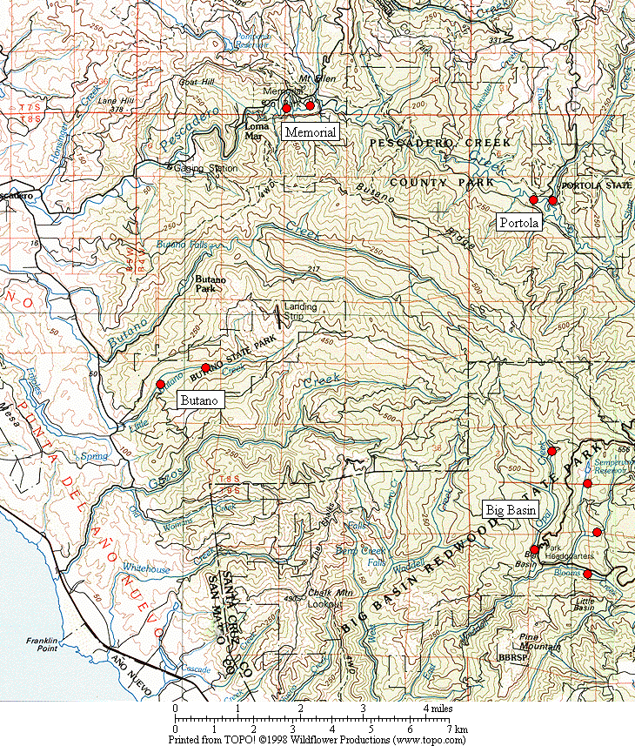

Figure 1. General location of the Marbled Murrelet monitoring stations in the four Santa Cruz Mountains parks.

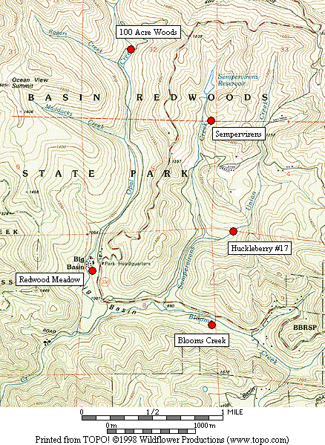

Figure 2. Location of Marbled Murrelet monitoring stations in Big Basin Redwoods State Park.

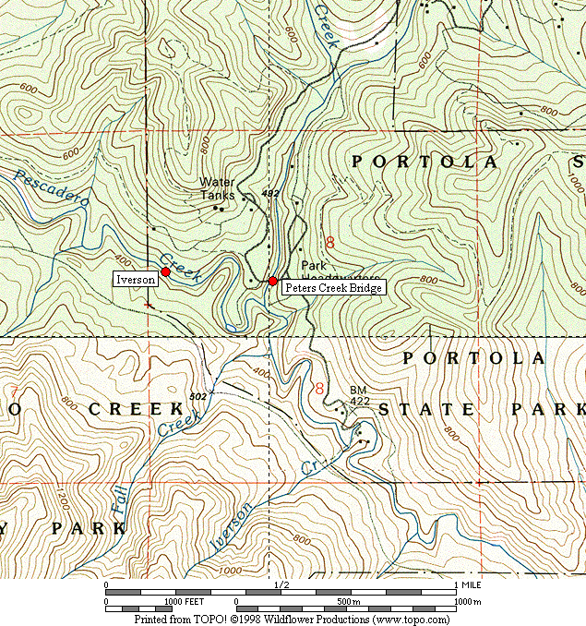

Figure 3. Location of Marbled Murrelet monitoring stations in Portola Redwoods State Park.

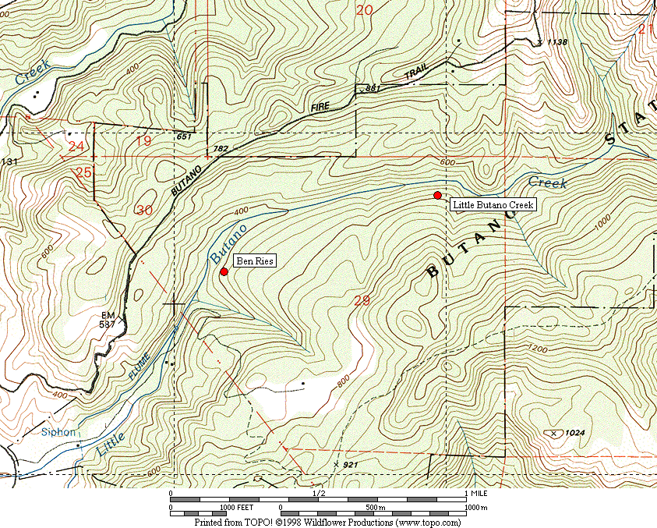

Figure 4. Location of Marbled Murrelet monitoring stations in Butano State Park.

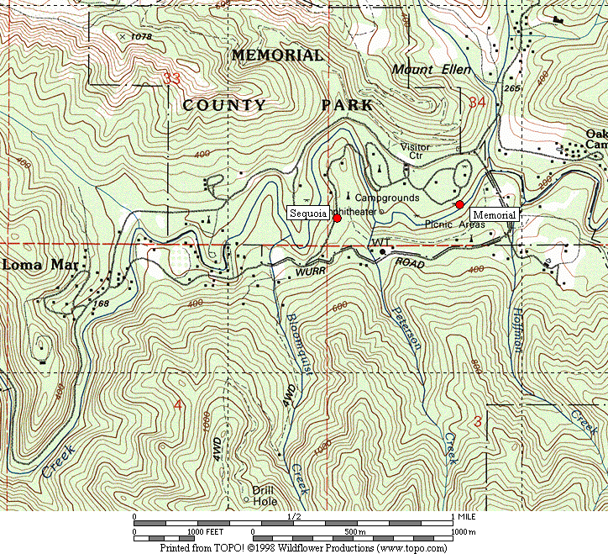

Figure 5. Location of Marbled Murrelet monitoring stations in San Mateo County Memorial Park.

Figure 6. Average murrelet activity on dawn surveys from all five Big Basin stations, 1995-2008. (Note: no data from 1997, 1999 or 2000.)

Figure 7. Average annual murrelet activity at all five Big Basin stations, showing total detections with polynomial regression trend, 1995-2008. (Note: no data from 1997, 1999 or 2000.)

A. “Redwood Meadow” B. “100 Acre Woods”

C. “Blooms Creek” D. “Huckleberry” (Note: no
detections were recorded in 2002 or 2008)

E. “Sempervirens” (Note: no detections
were recorded from 2002 to 2008)

Figure 8. Annual activity levels (average total detections) at individual Big Basin monitoring stations from 1995 – 2008. (Note: no data for 1997, 1999 or 2000. See table 2 for standard deviations)
Figure 9. Average detections from dawn surveys on three consecutive mornings in late June or early July at “Peters Creek Bridge,” Portola Redwoods State Park, 1992-2008. (Note: no data from 1996, 1997, 1999, or 2000.)

Figure 10. Linear regression on average detections from dawn surveys on three consecutive mornings at “Peters Creek Bridge” in Portola Redwoods State Park, 1992 to 2008. (Note: no data from 1996, 1997, 1999, or 2000.)

Figure 11. Relative levels of Marbled Murrelet activity at each park in 2003 to 2008 using total detections.

Figure 12. Relative levels of Marbled Murrelet activity at each park in 2003 to 2008 using detections with occupied site behavior.

A. “Peters Creek Bridge”, Portola B. “Iverson”, Portola C. “Ben Ries”, Butano

D. “Little Butano Creek”, Butano E. “Memorial”, Memorial F. “Sequoia”, Memorial

Figure 13. Annual activity levels (average total detections) at individual monitoring stations from 2003-2008 at Portola, Butano and Memorial parks. (Note: scales for the y-axis vary; see table 2 for standard deviations)

32

- Individual Parks

- All Parks Combined

Figure 14. Average number of Steller’s Jays (A) per station in each park 2001-2008, and (B) in all parks combined 2003-2008. (Notes: Data from dawn murrelet surveys, using maximum count per year for each station. Jay numbers from 10-minute point counts. Only Big Basin stations were surveyed in 2001-2002).

A. Individual Parks

B. All Parks Combined

Figure 15. Average number of Common Ravens (A) per station in each park 2001-2008, and (B) in all parks combined 2003-2008. (Notes: Data from dawn murrelet surveys, using maximum count per year for each station. Raven numbers from 2-hour surveys. Only Big Basin stations were surveyed in 2001-2002).

Figure 16. Average number of Marbled Murrelet detections for all parks combined in 2003-2008.
Appendix 1. Bird species detected and point count maxima from 2008 dawn Marbled Murrelet surveys. (See footnote for key to station codes.)¹

Big Basin Portola Butano Memorial

Species RM BC HU OA SP PC IV BR LB ME SQ

Wood Duck – – – – – – 1 – – X² –
Common Merganser – – – – – – – – – 1 X
Great Blue Heron X – – X – – – – – –
Green Heron – – – – – – – – – – X
White-tailed Kite – – – – – 1 – – – – –
Sharp-shinned Hawk X – – – – – – 3 – – –

Cooper’s Hawk – – 1 – X – – – – – –
Red-shouldered Hawk 1 – 1 – 1 X 1 1 – 2 2
Marbled Murrelet ³ 5 X – 2 – 6 4 7 8 X 5
Band-tailed Pigeon 5 8 4 5 3 3 2 2 3 3 3
Mourning Dove – 1 – – – – – – – – 1
Western Screech-Owl X – – X X X – – – – –

Northern Pygmy-Owl 2 1 1 1 – 1 – X 1 – –
Northern Saw-whet Owl – X – – – – – – – – –
Vaux’s Swift 1 X – – – 2 – – – – –
Allen’s Hummingbird – – – – – X X 1 1 – 1
Belted Kingfisher – – – – – 1 X – – 1 –

Appendix 1, continued

Big Basin Portola Butano Memorial

Species RM BC HU OA SP PC IV BR LB ME SQ

Acorn Woodpecker 12 18 20 1 4 6 – X 1 4 14
Hairy Woodpecker – 3 2 2 2 3 1 1 3 2 2
Northern Flicker 1 X 1 – 1 2 X – – 1 3
Pileated Woodpecker 3 4 4 3 5 2 – 2 2 3 2
Pacific-slope Flycatcher 1 2 X 5 4 4 4 4 3 2 1
Black Phoebe X – – – – – – – – 1 –

Hutton’s Vireo 2 1 1 1 1 X 1 – 1 2 2
Warbling Vireo – X – – X – – – – – –
Violet-green Swallow 1 – – – – – X – X 2 1
Steller’s Jay 7 8 32 4 3 10 2 6 5 9 25
American Crow – – – – – – – – – 1 –
Common Raven 5 X 5 – 2 2 X X 1 4 2
Chestnut-backed Chickadee 2 3 5 4 5 4 2 2 5 5 4

Bushtit – – – – – – – – – – X
Pygmy Nuthatch 4 10 7 3 4 6 4 2 1 6 5
Brown Creeper 3 4 4 3 2 2 3 2 3 4 4
Winter Wren 2 2 X 2 3 2 3 3 3 2 2
American Dipper – – – – – X – – – 1 –
Golden-crowned Kinglet 1 2 X 1 1 2 1 2 2 X 2
Hermit Thrush 1 4 3 2 2 1 1 2 2 X 2

Appendix 1, continued

Big Basin Portola Butano Memorial

Species RM BC HU OA SP PC IV BR LB ME SQ

Swainson’s Thrush 4 – – – – 2 2 1 – 1 1
American Robin 4 3 3 2 1 3 2 2 1 1 3
Varied Thrush – – – – – – – – 1 – –
Wrentit X 4 – – – – – – – – –
Wilson’s Warbler 2 3 1 1 1 1 3 2 3 1 1
Spotted Towhee X 2 4 – – – – – – – –

California Towhee – – – – – – – – – 1 2
Black-headed Grosbeak 1 1 1 – X – – – – 1 –
Dark-eyed Junco 4 X 2 2 2 X – 1 X 3 2
Red Crossbill – – – – – – – 3 – – –
Purple Finch X 1 – 1 X 1 X 1 X X X
Pine Siskin – – – – – – – 1 2 1 2

1. Station codes: RM (Redwood Meadow), BC (Blooms Creek), HU (Huckleberry #17), OA (100 Acre Woods), SP (Sempervirens), PC (Peters Creek
Bridge), IV (Iverson Trail), BR (Ben Ries), LB (Little Butano Creek), ME (Memorial), SQ (Sequoia).
2. “X” denotes a species detected during a 2-hour survey, but not detected during any point count.
3. Number given for Marbled Murrelet is the best estimate of different individuals from one or more detections during a point count.
Appendix 2. Comprehensive Summary of Dawn Marbled Murrelet Surveys at Redwood Meadow / Park Headquarters Area in Big Basin Redwoods State Park 1991-2008.

In addition to the 41 dawn surveys conducted at Redwood Meadow specifically for the California Dept. of Fish and Game (1995-2002) and the COSTC (2003-2008), Suddjian conducted 181 additional surveys from 1991-2008 at Redwood Meadow and the adjacent parking lot at Park Headquarters, for a total of 222 dawn surveys conducted there over the 18 year period (92% by Suddjian). In 2008 Suddjian conducted 16 additional surveys at the Redwood Meadow / Park Headquarters parking lot area from April 21 to July 27, beyond the three called for by COSTC contract, for 19 total surveys in 2008. An average of 12.3 dawn surveys (range 6-19 surveys) have been conducted annually, with 16-19 per year since 2002 (Figure 2-1).

The meadow and parking lot are 70 meters apart, and both offer an expansive view of the sky. Surveys in both spots sample largely the same activity, and auditory and some visual detections overlap broadly between the two stations (D. Suddjian pers. obs.). Thus, survey results from these adjacent spots are combined here to provide a long-term trend in murrelet activity in the park headquarters area. Additionally, the surveys span April to July, and so sample a broader portion of the murrelet nesting season than the current June-July COSTC monitoring scheme.

Murrelet activity in 2008 remained very low at Redwood Meadow / Park Headquarters compared to activity in the early 1990s (Figures 2-2 and 2-3), with a highly significant declining trend evident for total detections (r² = 0.918, P <0.0001) and those with occupied site behavior (r² = 0.836, P <0.0001). Activity levels in 2008 remained at a continued low ebb that has been observed since 2002 (Figure 2-4), however 58 detections on May 8, 2008 were more than on any other survey at this location since 2002. There were very few detections of occupied site behavior (only a total of five from all 19 surveys), and the average number of occupied site detections tied the record lowest set in 2005. Surveys in 2008 included four mornings with zero detections, and six with just 1-5 detections. Annual medians, maxima, and minima have exhibited the same declining pattern, with the median values quite close to the minima since 2001 (Figure 2-5). The typical seasonal activity peak expected in July has only occurred in one year since 2001 (Figure 2-6). In 2008 it occurred in May.

Figure 2-1. Number of dawn surveys conducted annually at the Redwood
Meadow / Park Headquarters area in Big Basin from 1991-2008.

Figure 2-2. Average number of total detections (± s.d) on dawn surveys at Redwood
Meadow / Park Headquarters, 1991-2007. (Note: see Figure 2-1 for annual sample
sizes. Surveys occurred between April 5 and July 31 each year.)

Figure 2-3. Average number of occupied behavior detections (± s.d) on dawn
surveys at Redwood Meadow / Park Headquarters, 1991-2007. (Note: see Figure
2-1 for annual sample sizes. Surveys occurred between April 5 and July 31 each year.)

Figure 2-4. Average number of detections on dawn surveys at Redwood
Meadow / Park Headquarters for 1998-2008 (Note: see Figures 2-2 and 2-3
for standard deviations.)

Figure 2-5. Annual median, maximum and minimum total detections on dawn
surveys at Redwood Meadow / Park Headquarters in Big Basin, 1991-2008.

Figure 2-6. Monthly average number of detections on dawn surveys at Redwood Meadow / Park Headquarters in Big Basin, 1991-2008.

Appendix 3. Summary of Marbled Murrelet Detections During Coverage of a Breeding Bird Survey Route in Big Basin Redwoods State Park, 1992-2008.

The “Pescadero, CA” route (#14-319) is part of the USGS’s Breeding Bird Survey (BBS). The route begins in Big Basin on Hihn-Hammond Road just west of Blooms Creek Campground, and proceeds (via Gazos Creek Road, Cloverdale Road, and Pescadero Road) for 24.5 miles to San Mateo County Memorial Park. Birds are surveyed for three minutes at 25 stops located every 0.5 mile. The route passes through various areas of suitable Marbled Murrelet habitat, but over this route’s history murrelets were only detected at the first 10 stops (Figure 3-1); the remaining areas of suitable habitat along the route are not reached until after flight activity has ceased for the morning.

Suddjian initiated the “Pescadero, CA” BBS route in 1992, and has sampled it in most years since then. Each survey has occurred between May 29 and June 1. Official results for 1992-1997, and 2001-2008 are available at < http://www.pwrc.usgs.gov/bbs/ >. The route could not be covered in its entirety during 1998-2000 due to road washouts and problems with access through a gate along Gazos Creek Road. But in all years except 2000 Suddjian at least surveyed the beginning portion of the route in Big Basin, including all the stops where murrelet activity has been recorded (Figure 3-1).

While the BBS method is not specifically designed for monitoring murrelets at forest sites, it does provide a repeated measure of murrelet activity, and coverage for the BBS at Big Basin was contemporaneous with the other monitoring efforts presented in this report. The first three stops at the very beginning of the route (Figure 3-1) are located in the East Waddell / Opal Creek watersheds in areas that through the early 1990s had very high levels of activity.

Murrelet activity recorded on the “Pescadero, CA” BBS route exhibited a pattern of decline from 1992 – 2008 that closely paralleled the decline recorded by the other Big Basin monitoring efforts (Figure 3-2; cf. Figure 7 and Appendix 2). Three related measures – (1) total detections, (2) total estimated individuals, and (3) the number of stops where murrelets were recorded – all showed the same pattern. The number of detections showed a highly significant declining trend (r² = 0.658, P = <0.0001). In most recent years most of the few detections recorded have been from birds in the West Waddell watershed, and not at Big Basin proper.

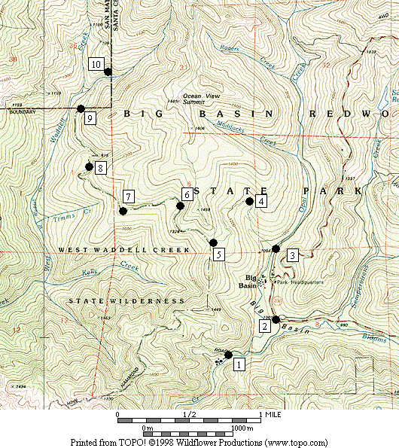

Figure 3-1. Stops on the Breeding Bird Survey route “Pescadero, CA” (#14-319) where Marbled Murrelets were detected on surveys in 1992-2008.

Figure 3-2. Marbled Murrelet activity recorded within Big Basin Redwoods State Park on the "Pescadero, CA” Breeding Bird Survey route in 1992 to 2008. (Note: No data for 2000; no detections in 2005.)

